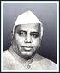

**Rayat Shikshan Sanstha’s**

# YASHAVANTRAO CHAVAN INSTITUTE OF SCIENCE,

**SATARA (AUTONOMOUS )**

**DEPARTMENT OF B.Sc (CS)**

**(Part III)**

**A PROJECT REPORT ON**

***“ DIGITAL KHATA (PAVER)”***

**SUBMITTED BY**

**SUDHANSHU SUNIL KADAM**

**VAISHNAV MADHUKAR JADHAV**

**UNDER THE GUIDANCE OF**

**Prof. .**

**SHIVAJI UNIVERSITY, KOLHAPUR.**

## YEAR 2021-2022

**Roll No*.***  **Exam Seat No.** 

***“Education through self-help is our motto”*-KARMAVEER.**

**Rayat Shikshan Sanstha’s**

# YASHAVANTRAO CHAVAN INSTITUTE OF SCIENCE,

**SATARA (AUTONOMOUS )**

**DEPARTMENT OF B.Sc (CS)**

**(Part-III)**

Date :- - -2022

This is to certify that partial fulfillment of curriculum of T.Y.B.C.S.

Student **Mr. Sudhanshu sunil kadam** has successfully completed the project

Working the Computer Science entitled **“Digital Khata (Paver)”** prescribed by,

The **SHIVAJI UNIVERSITY, KOLHAPUR** and this project report represents Her bonafide work in year **2021-2022.**

**PROJECT GUIDE EXAMINER HEAD, Dept. Of B.Sc (CS)**

**Roll No*.***   **Exam Seat No.** 

***“Education through self-help is our motto”*-KARMAVEER.**

**Rayat Shikshan Sanstha’s**

# YASHAVANTRAO CHAVAN INSTITUTE OF SCIENCE,

**SATARA (AUTONOMOUS )**

**DEPARTMENT OF B.sc (cs)**

**( Part-III)**

Date :- - -2022

This is to certify that partial fulfillment of curriculum of T.Y.B.C.S.

Student **Mr. Vaishnav Madhukar Jadhav** has successfully completed the project

Working the Computer Science entitled **“Digital Khata (Paver)”** prescribed by,

The **SHIVAJI UNIVERSITY, KOLHAPUR** and this project report represents Her bonafide work in year **2021-2022.**

**PROJECT GUIDE EXAMINER HEAD, Dept. of B.Sc (CS)**

# ACKNOWLEDGEMENT

A good project is result of lot of efforts of many people who are involved directly or indirectly. We take opportunity to gracefully thank to all those people without whom this project would not have succeeded. Each of them has their own special way contributed towards the success of this project.

There are so many people directly or indirectly to complete this project. We shall mention few of them who are personally encouraged and assist us in entire duration of project are a very pleasant endeavor.

We are thankful to our project guide **Mr. P. H. Gharge**

***Mr. J. A.wagh (Head of B.Sc (CS) department)*** for his consistence motivation and encouragements. We are also honestly thankful for our all friends who give us their valuable suggestion about our project and help us to complete this project.

**Mr. Sudhanshu Sunil Kadam**

**Mr. Vaishnav Madhukar Jadhav**

**INDEX**

|  |  |  |
| --- | --- | --- |
| **Sr. No.** | **Context** | **Page No.** |
| 1. | **Introduction**  1.1 Introduction to System  1.2 Abstract  1.3 Existing System  1.4 Scope  1.5 Organization Profile |  |
| 2. | **Proposed System**  2.1 Objectives  2.2 Requirement Engineering  ● SRS |  |
| 3. | **System Analysis**  3.1 DFD  3.2 ERD  3.3UML Diagrams Use case diagram  Activity diagram  Sequence diagram |  |
| 4. | **System Design**  4.1 Database design  4.2 Input and Output design |  |
| 5. | **System Requirement**  Hardware  Software |  |
| 6. | **Output**  Screens and Reports |  |
| 7. | **Conclusion**  7.1 Advantages  7.2 Conclusion  7.3 Limitation |  |
| 8. | **Bibliography** |  |

# INTRODUCTION

## 1.1 Introduction to system

The main objective of the project is to create an online platform that allows users to search and make a booking enquiry based on paver type. Using this platform the user can view all company details like products, client review, their portfolio instead of going out to a store and wasting time.

In current, company owner take booking order on a register. They manage customer record on register. And also it is very difficult to maintain all product details in this shop. Making report for the book store is also very tiresome task.

So to overcome this problem we develop this platform so company owner will easily track client order history and payment history. Customer can also check the review of other customer. It helps him to take decision of taking the services of a particular Company. This system helps both the customer and the book store owner.

**\* Modules**

**1) Admin Module :**

1. **Product Section -** Ability to Add or remove product from the database and to update products.
2. **Order Section -** see order enquiry from users and make decision on confirmation.

**C . Portfolio -** Ability to Add or remove client portfolio from the database and to update portfolio.

1. **Company Profile -** Easily Update Company Profile
2. **Register User -** Track Register User

**2) User Module :**

1. Register
2. login
3. Make Order request
4. Track order and payment history
5. Add/Update Feedback
6. Update profile info

## 1.2 Abstract

The objective of this website is to create a platform for people where they can information about paver blocks development group and this development group also get information about their previous and next clients. Paver blocks can be used anywhere. They looks great on the drives and will provide many years of service. The main thing it is easy to cleaning, environment friendly and easy to repair.

## 1.3 Existing system

The existing system is paper based, time consuming , less flexible and provides very hectic working schedule.

**1. Lack of space:**

It became a problem in itself to find space to keep the more files or mustard.

**2. Filing poses a problem:**

Filling the documents categorically is a time consuming and tedious exercise.

1. **Filtering is not easy:**

It became hard to filter relevant document for the irrelevant ones if the count of the same crosses a certain manageable number.

1. **Labor:**

In the existing system the number of staff required for completing the work’s more. Thus, overall process is time consuming.

## 1.4 Scope

Manually system is time consuming process and computerized process is time saving process.

New thing in this system which is suggest that there is no duplication of questions in exam paper.

## 1.5 Organization Profile

**CLIENT LETTER**

To whom it may concern,

Client Name:

Student Name:

As Students Of Yashwantrao Chavan Institute of Science, Satara (B.Sc.Computer Science (B.Sc.)) stated me about the project

I am Pleased to inform you that I am ready to client for assigned to the students.

The scope and working of the project is useful for those who prefer to orders the paver block products . So I think this project is useful for everyone.

Email: -

Contact no:

Date:

Client Signature

## 2 Proposed System

Overcome the problems of the existing system by making it computerized

Cost required in the proposed system is comparatively less to the existing system.

All paver block information, booking information will be store very accurate in the database.

### 2.1 Objectives of System

* To save time and money.
* To save an accurate information.
* To prepare a system that reduces processing time.
* To enhance the work like maintaining all record and regular updating.
* The main aim to develop this software is to provide the question sets.
* To reduce drawbacks of manual system.
* To reduce paper work.

## 2. 2 Requirement Engineering

**System Requirement Specification**

Software requirement is functional or non-functional need to be

implemented in the system. Function means providing particular service to user.

**Functional Requirement:** Admin will allow to access update, correct and management their information.

* **Requirement Gathering :**

We present intelligent models for automated requirements gathering

for computerized career guidance system. While analyzing the this management process we discover that there are several task that are being perform independently and for tasks multiple intelligent can be created. These agents can be made to gather requirements automatically even after the deployment of the system if the requirement gathering.

* **SRS :**

**Feasibility Study:**

Feasibility analysis begins once the goals are defined. It starts by

generating possible solutions, which are possible to give an indication of what the new system should look like. This is creativity and imagination is used. Analysts must think up new ways of doing things generate new ideas. There is no need to go into the detailed system operation. The solution should provide enough information to make reasonable estimates about project cost and give users an indication of how the new system will fit into the organization. Feasibility of a new system means ensuring that the new system, which we are going to implement, is efficient and affordable. There are various types of feasibility to be determined.

1. **Economical Feasibility:**

Development of this application is highly economically feasible. The

Only thing to be done is making an environment with an effective supervision. It is cost effective in the sense that has eliminated the paper work completely. The system is also time effective because the report are match within second and displays paver blocks.

1. **Technical feasibility:**

The technical requirement for the system is economic and it does not use any other additional Hardware and software. Technical evaluation must also assess whether the existing systems can be upgraded to use the new technology and whether the organization has the expertise to use it.

Install all upgrades XAMPP into the php package supported windows based application. This application depends on Microsoft office and intranet service, database.

1. **Operational Feasibility:**

The system working is quite easy to use and learn due to its simple but attractive interface. User requires no special training for operating the system. Technical performance include issues such as determining whether the system can provide the right information .

## 3. System Analysis System Diagram

### 3.1 Data Flow Diagram (DFD)

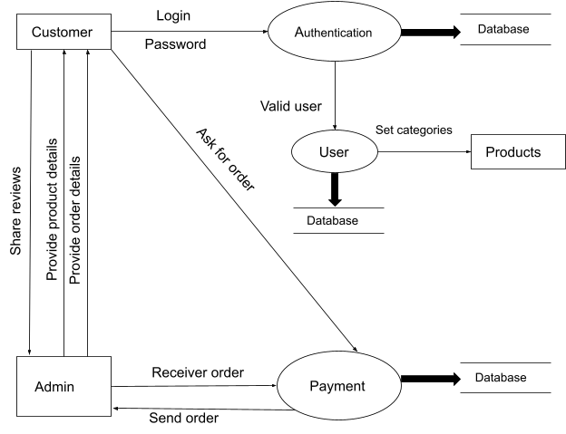

### 3.2 Entity Relationship Diagram (ERD)

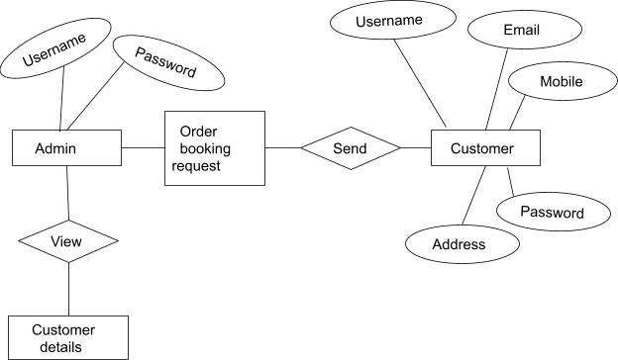

**3.3 UML Diagrams**

## Use case diagram­­

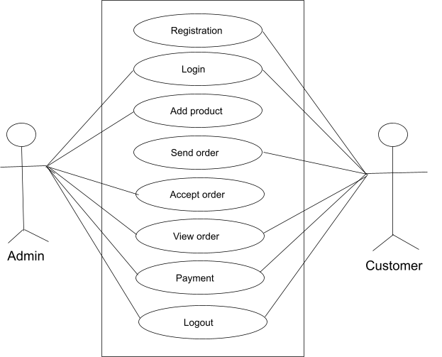

## Activity Diagram

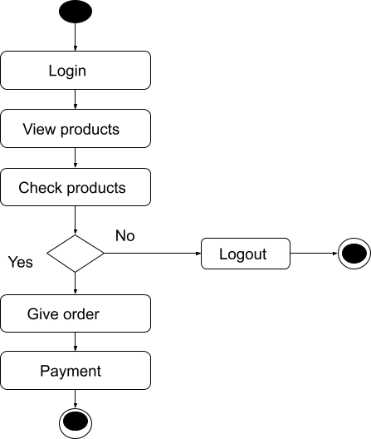

## Sequence Diagram

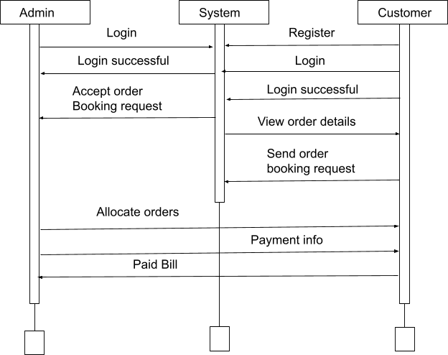

1. **. System Design**

**4.1 Database Design**

**User registration table :**

This table shows the User registration information.

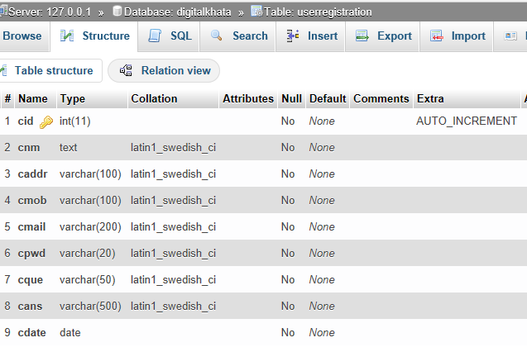

**Admin information table :**

This table shows Admin information.

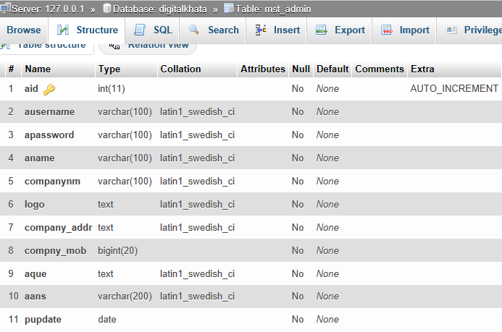

**Product details table :**

This table shows product details.

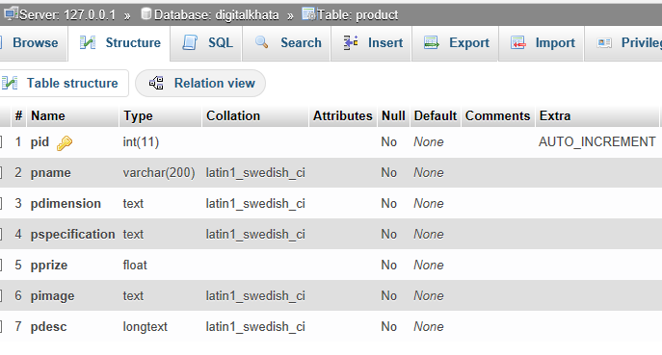

**Portfolio table :**

This table shows Portfolio.

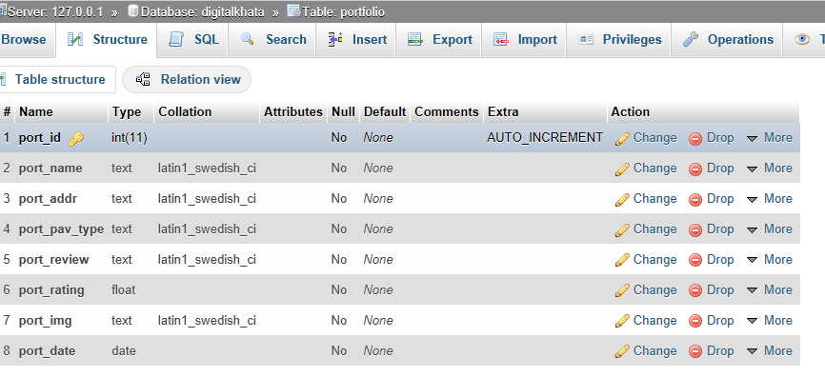

**Order details table :**

This table shows Order details.

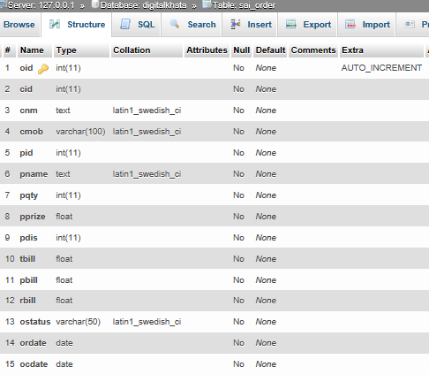

**Contact details table :**

This table shows Contact details.

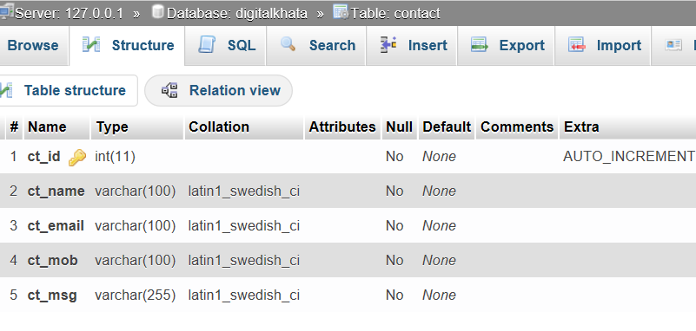

**Feedback table :**

This table shows Feedback information.

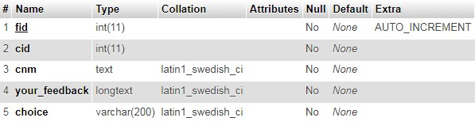

### 4.2 Input and Output Design

**Home Page :**

This is the Home page. In this page we provide Login and Registration link for users and customers.This is the static web page.

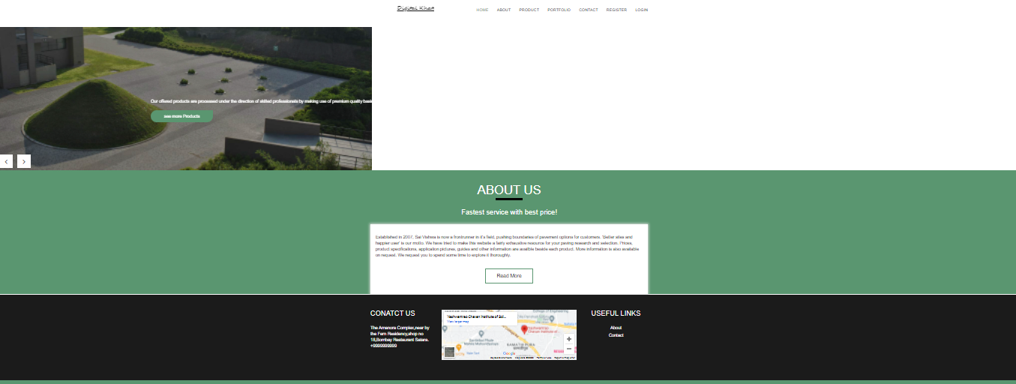

**About Page** :

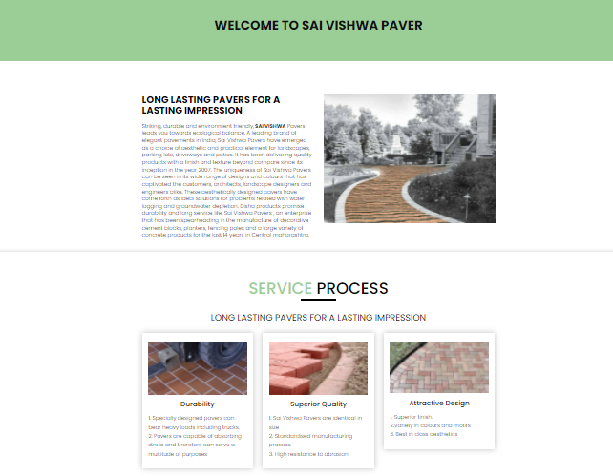

**Product List Page :**

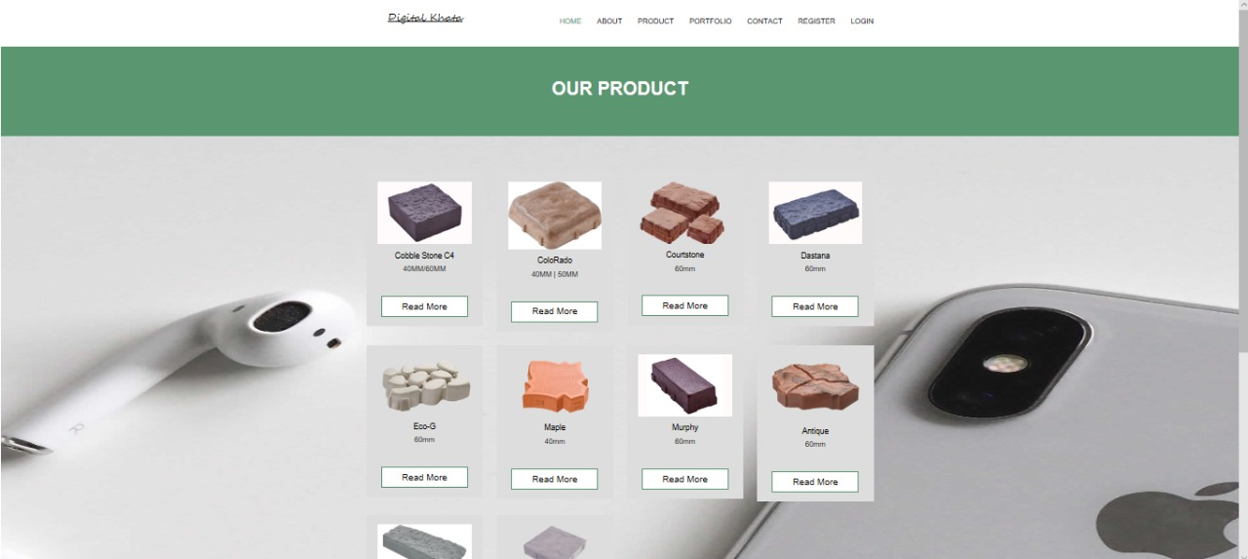

**product-info-without-login :**

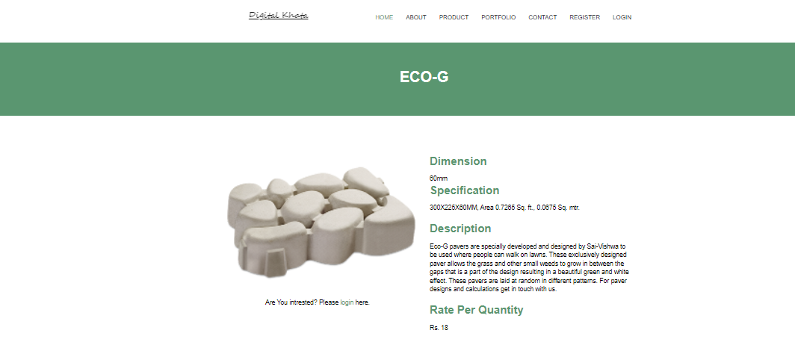

**Registeration page :**

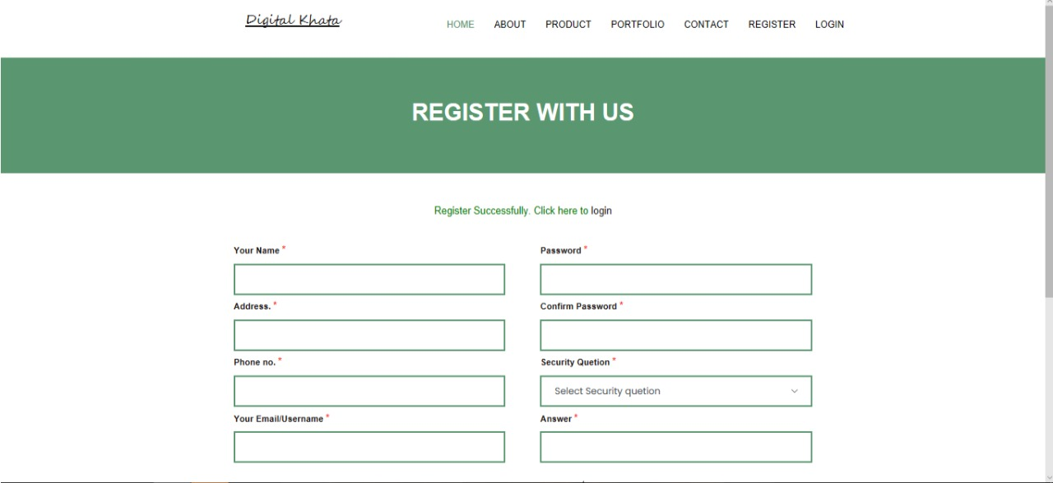

**Login page :**

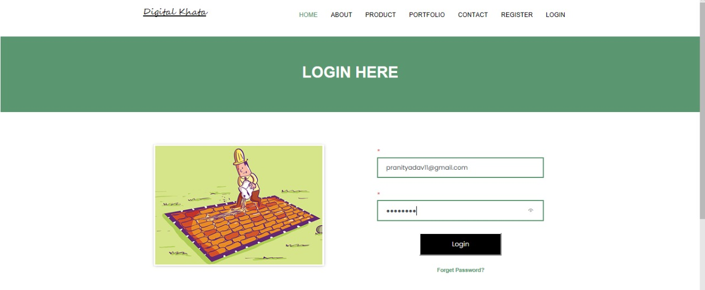

**Send Enquiry about product :**

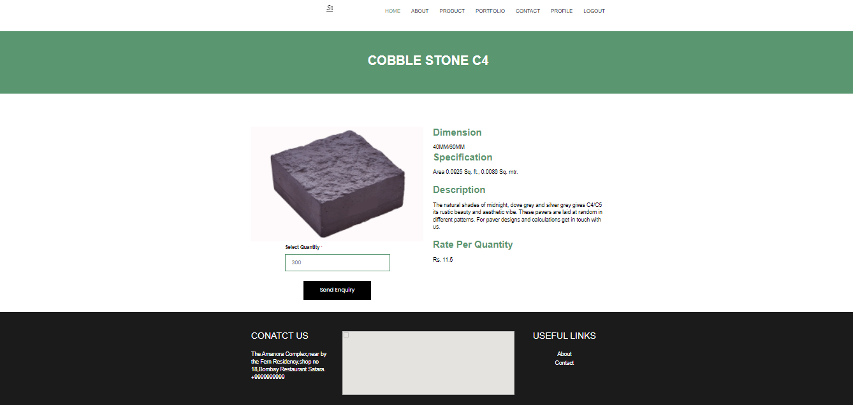

**Order history :**

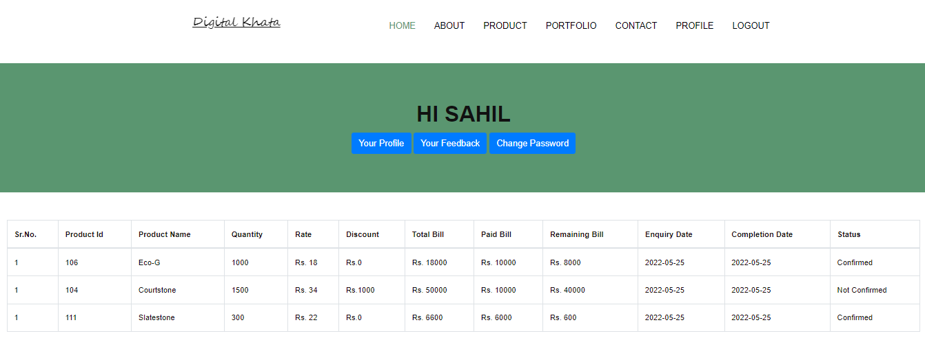

**User feedback :**

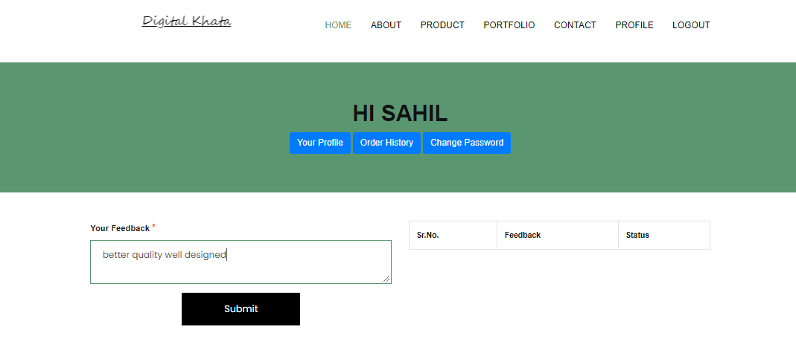

**Profile :**

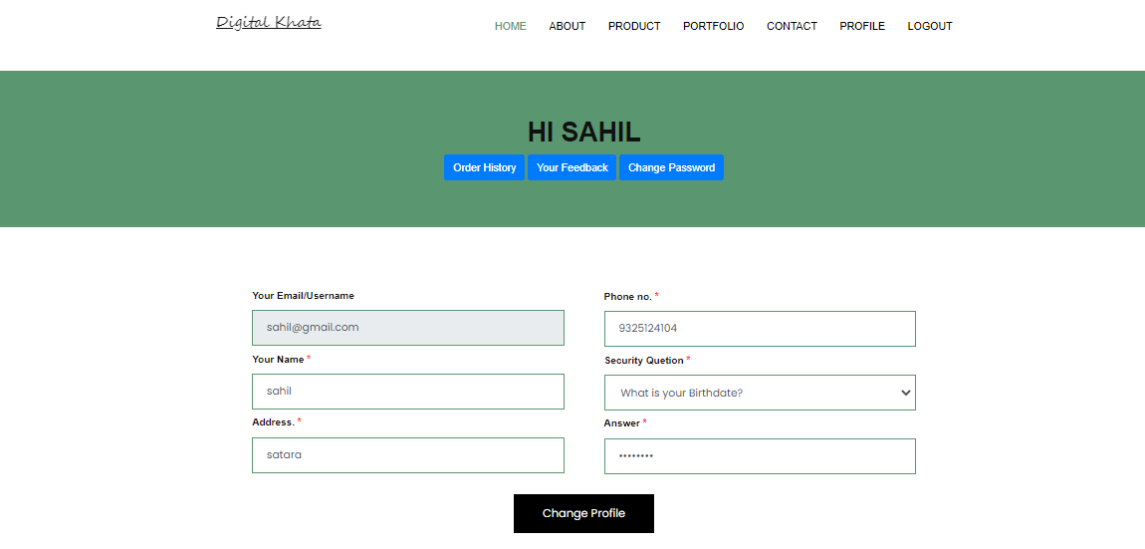

**Reset password :**

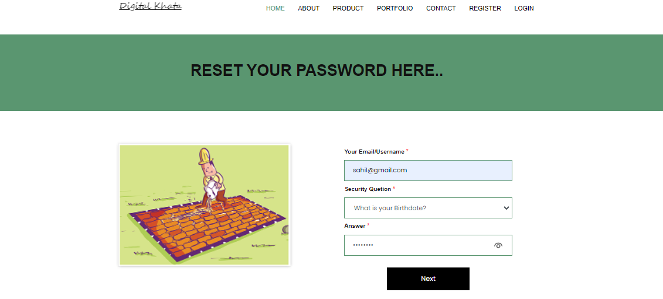

**Change password :**

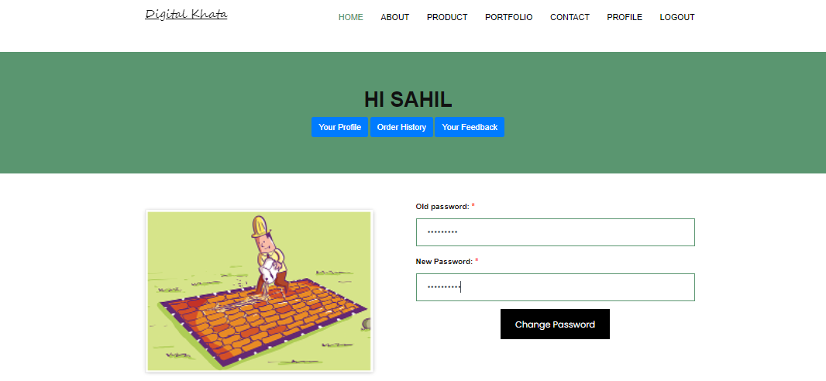

**Contact page :**

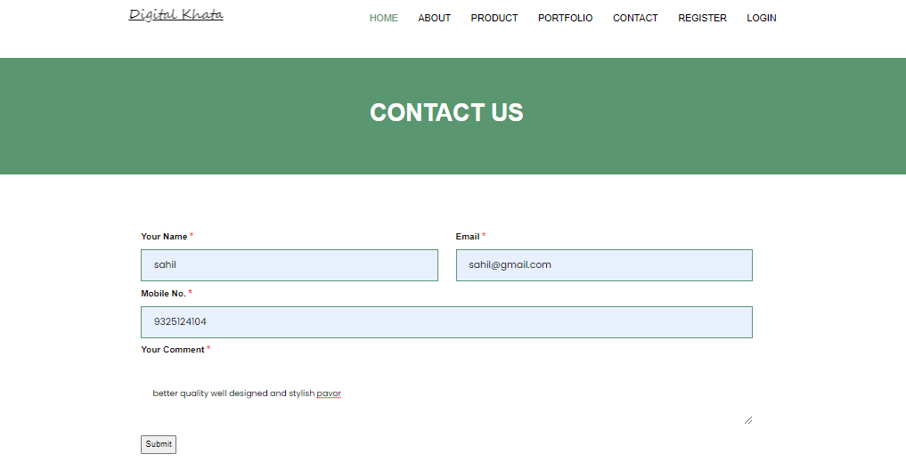

**Admin side**

**Login:**

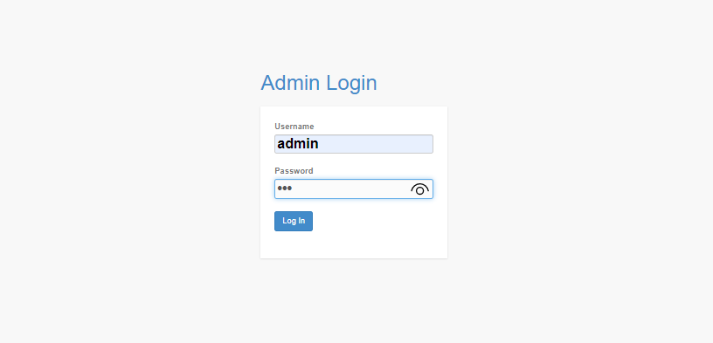

**Dashboard:**

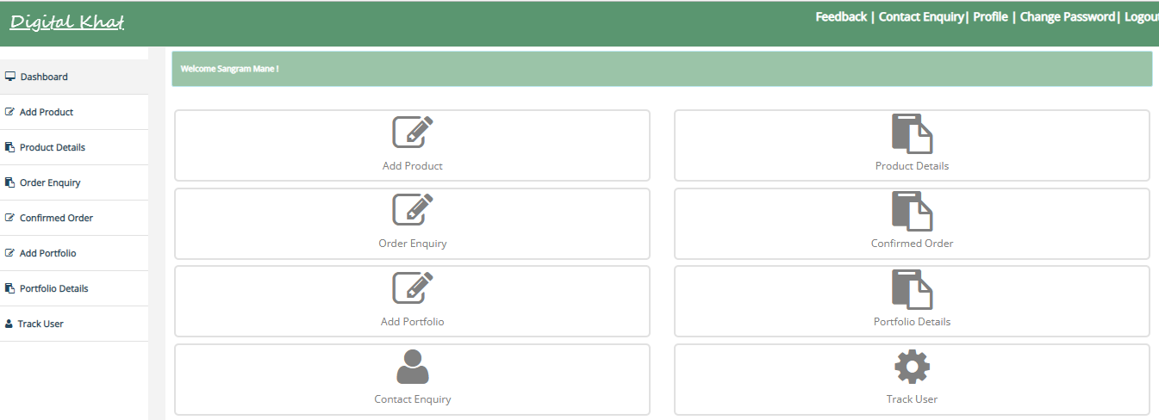

**Add product :**

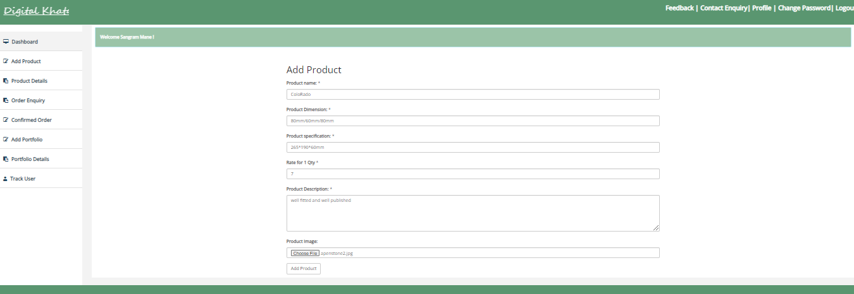

**Product details :**

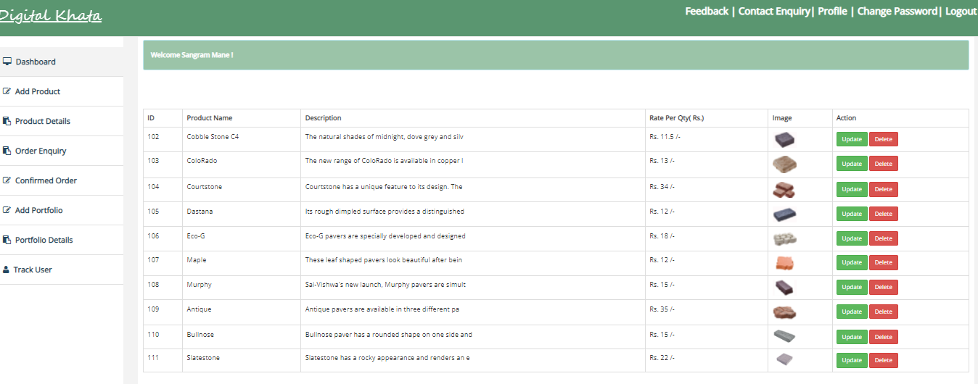

**Update product :**

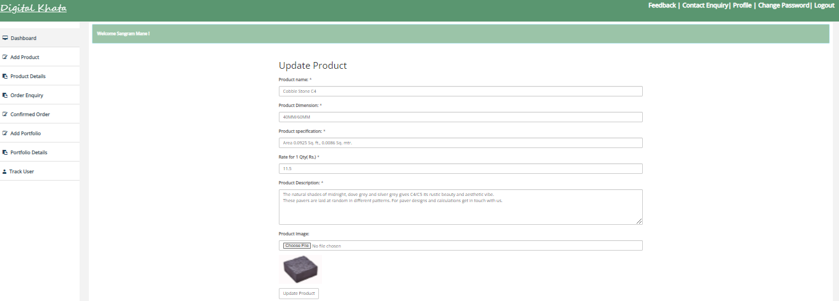

**Order enquiry :**

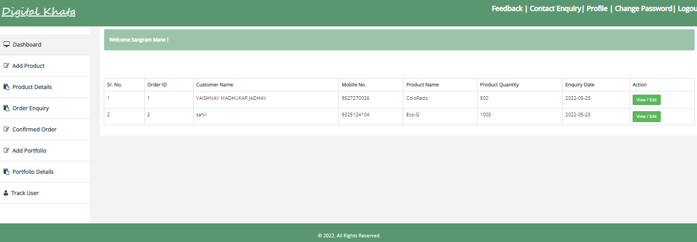

**Confirmed - order :**

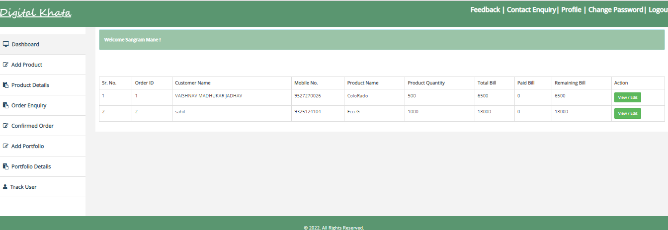

**Add portfolio :**

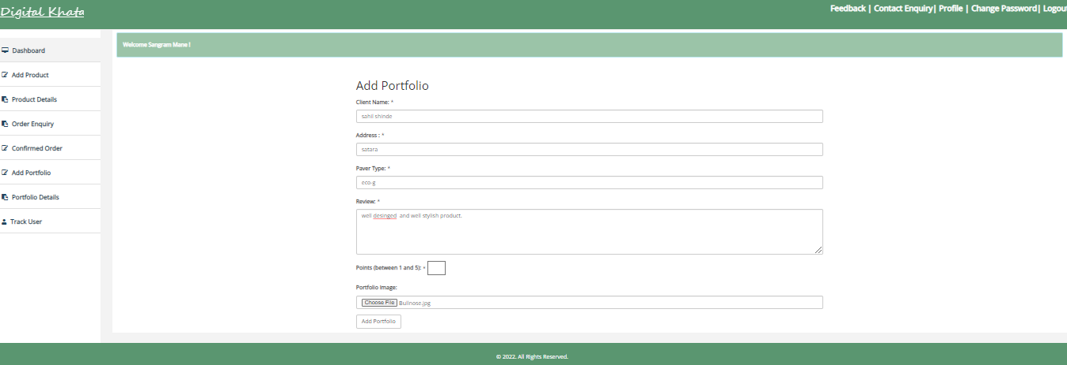

**Portfolio details :**

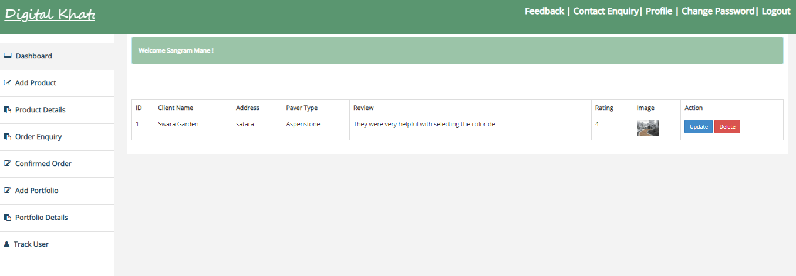

**Update portfolio :**

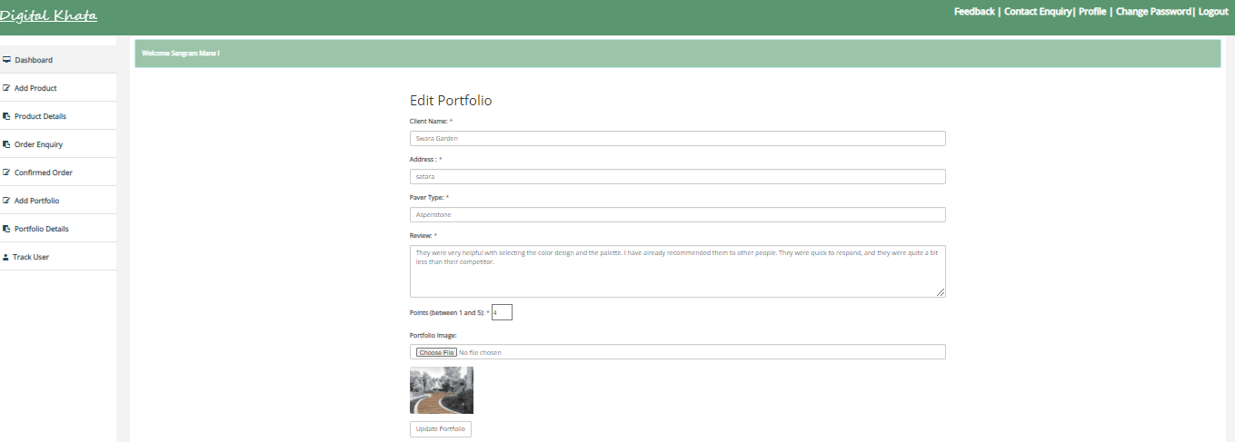

**Contact Enquiry :**

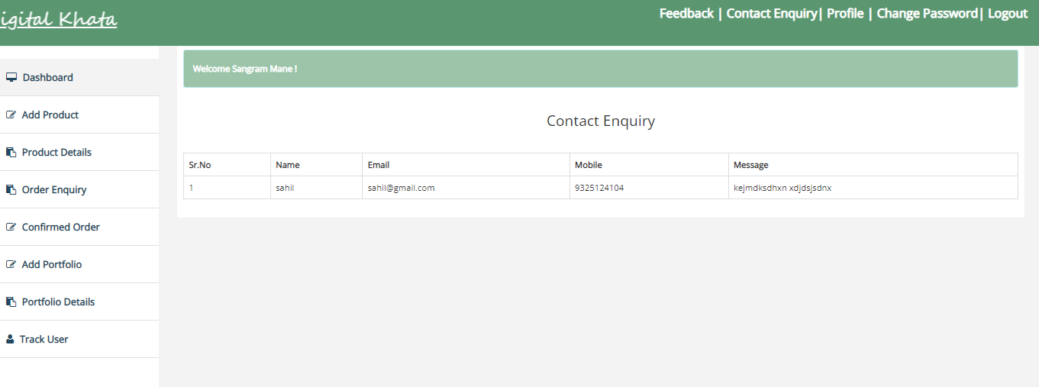

**User feedback :**

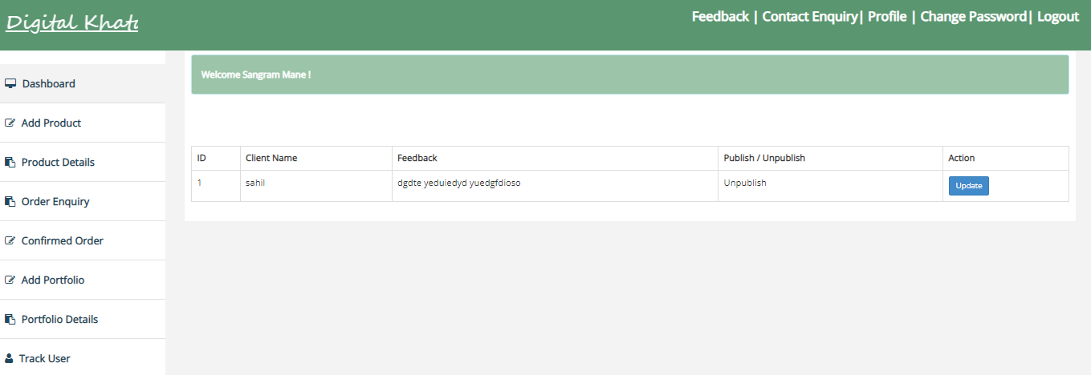

**Registration user :**

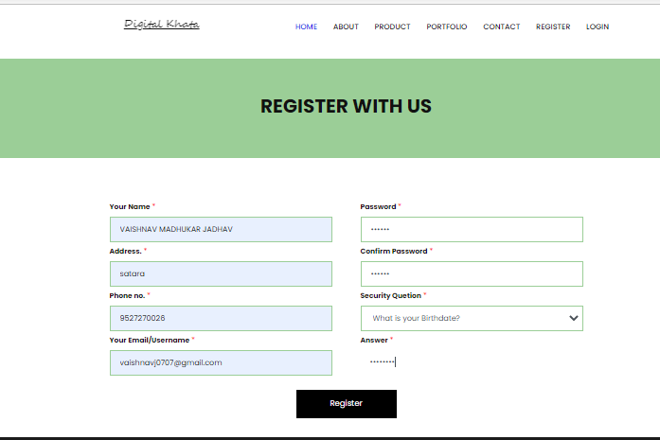

**Update Profile :**

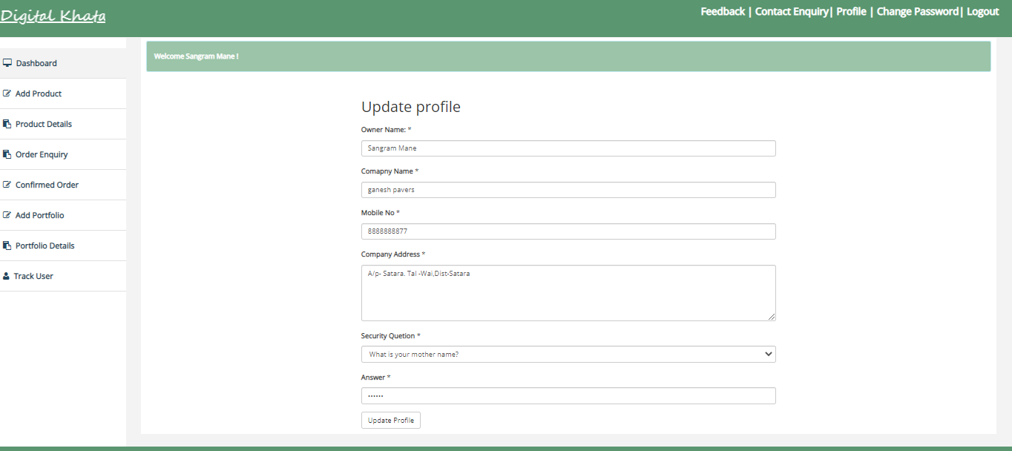

**Change password :**

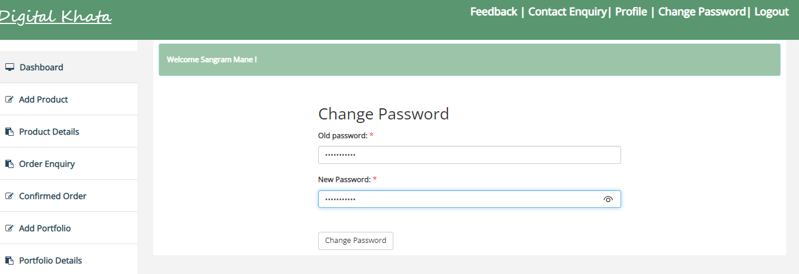

## 5. System Requirements

**Hardware:**

Processor:- Intel(R)Core (TM)2 Duo CPU T9400 @2.53GHz 2.53Hz

RAM: - minimum 512 MB and above.

Input devices:- Keyboard, Mouse

Hard Disk :- 4GB

**Software:**

Operating System - Windows 2000 and above.

Reporting Tools - Microsoft office.

Development - XAMPP

Front End - HTML, CSS, PHP, Java Script.

Back End - MySQL.

## 7 . Conclusion

### 7.1 Advantages

* Using this platform the user can view all company details like products, client review, their portfolio instead of going out to a store and wasting time.
* Help owner in tracking of Products, order and payment history.
* Reduce paper work.
* As long as the browser is compatible, this can run on multiple platforms regardless of the operating system or device.

### 7.2 Conclusion

This application helps customer to check the products and give the

order. This is also helpful for admin to collect the correct information in database.

It reduces the paper work .

### 7.3 Limitations

The limitations of this system are as follows :

1.Without internet customer can not give a order

2.Regional language is not supported.

**8 . Bibliography**

**Book Referred :**

PHP and MY SQL

- Rajendra Salokhe

Beginning PHP Apache , MYSQL web development - Timothy Boronczyle

**Website:**

[www.W3schools.com](http://www.w3schools.com/) [www.tutorialspoint.com](http://www.tutorialspoint.com/)